The V-model is an SDLC model where execution of processes happens in a sequential manner in a V-shape. It is also known as **Verification and Validation model**.

V-Model - Design

Under the V-Model, the corresponding testing phase of the development phase is planned in parallel. So, there are Verification phases on one side of the ‘V’ and Validation phases on the other side. The Coding Phase joins the two sides of the V-Model.

The following illustration depicts the different phases in a V-Model of the SDLC.

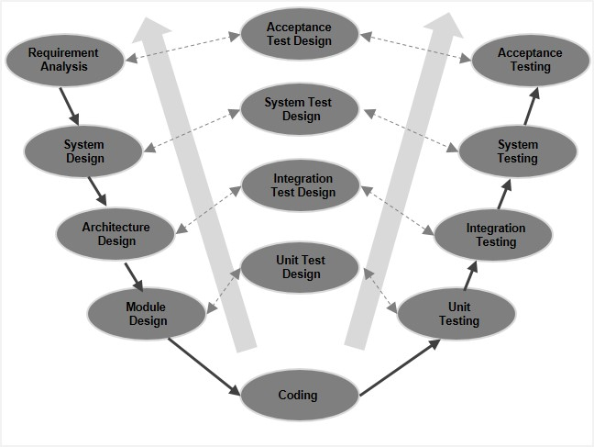

## V-Model - Verification Phases

There are several Verification phases in the V-Model, each of these are explained in detail below.

### **Business Requirement Analysis**

This is the first phase in the development cycle where the product requirements are understood from the customer’s perspective. This phase involves detailed communication with the customer to understand his expectations and exact requirement. This is a very important activity and needs to be managed well, as most of the customers are not sure about what exactly they need. The **acceptance test design planning** is done at this stage as business requirements can be used as an input for acceptance testing.

### **System Design**

Once you have the clear and detailed product requirements, it is time to design the complete system. The system design will have the understanding and detailing the complete hardware and communication setup for the product under development. The system test plan is developed based on the system design. Doing this at an earlier stage leaves more time for the actual test execution later.

### **Architectural Design**

Architectural specifications are understood and designed in this phase. Usually more than one technical approach is proposed and based on the technical and financial feasibility the final decision is taken. The system design is broken down further into modules taking up different functionality. This is also referred to as **High Level Design (HLD)**.

The data transfer and communication between the internal modules and with the outside world (other systems) is clearly understood and defined in this stage. With this information, integration tests can be designed and documented during this stage.

### **Module Design**

In this phase, the detailed internal design for all the system modules is specified, referred to as **Low Level Design (LLD)**. It is important that the design is compatible with the other modules in the system architecture and the other external systems. The unit tests are an essential part of any development process and helps eliminate the maximum faults and errors at a very early stage. These unit tests can be designed at this stage based on the internal module designs.

## Coding Phase

The actual coding of the system modules designed in the design phase is taken up in the Coding phase. The best suitable programming language is decided based on the system and architectural requirements.

The coding is performed based on the coding guidelines and standards. The code goes through numerous code reviews and is optimized for best performance before the final build is checked into the repository.

## Validation Phases

The different Validation Phases in a V-Model are explained in detail below.

### **Unit Testing**

Unit tests designed in the module design phase are executed on the code during this validation phase. Unit testing is the testing at code level and helps eliminate bugs at an early stage, though all defects cannot be uncovered by unit testing.

### **Integration Testing**

Integration testing is associated with the architectural design phase. Integration tests are performed to test the coexistence and communication of the internal modules within the system.

### **System Testing**

System testing is directly associated with the system design phase. System tests check the entire system functionality and the communication of the system under development with external systems. Most of the software and hardware compatibility issues can be uncovered during this system test execution.

### **Acceptance Testing**

Acceptance testing is associated with the business requirement analysis phase and involves testing the product in user environment. Acceptance tests uncover the compatibility issues with the other systems available in the user environment. It also discovers the non-functional issues such as load and performance defects in the actual user environment.

## V- Model ─ Application

V- Model application is almost the same as the waterfall model, as both the models are of sequential type. Requirements have to be very clear before the project starts, because it is usually expensive to go back and make changes. This model is used in the medical development field, as it is strictly a disciplined domain.

The following pointers are some of the most suitable scenarios to use the V-Model application.

* Requirements are well defined, clearly documented and fixed.
* Product definition is stable.
* Technology is not dynamic and is well understood by the project team.
* There are no ambiguous or undefined requirements.
* The project is short.

## V-Model - Pros and Cons

The advantage of the V-Model method is that it is very easy to understand and apply. The simplicity of this model also makes it easier to manage. The disadvantage is that the model is not flexible to changes and just in case there is a requirement change, which is very common in today’s dynamic world, it becomes very expensive to make the change.

The advantages of the V-Model method are as follows −

* This is a highly-disciplined model and Phases are completed one at a time.
* Works well for smaller projects where requirements are very well understood.
* Simple and easy to understand and use.
* Easy to manage due to the rigidity of the model. Each phase has specific deliverables and a review process.

The disadvantages of the V-Model method are as follows −

* High risk and uncertainty.
* Not a good model for complex and object-oriented projects.
* Poor model for long and ongoing projects.
* Not suitable for the projects where requirements are at a moderate to high risk of changing.
* Once an application is in the testing stage, it is difficult to go back and change a functionality.
* No working software is produced until late during the life cycle.